GROUP 8

Supervised by  Mr. Andre MBAKOP

DRONE’S ARM OPTIMIZATION

# DRONE’S ARM OPTIMIZATION

There are several ways to improve the strength of a drone arm

o Use high quality materials in the construction of the arm such as aluminum or carbon fibers.

o Reinforce the arm with additional structural components such as gussets or spacers

o Increase the diameter of the arm to increase its strength to weight ratio

o Use structural adhesives to glue the different parts of the arm together

o Add extra layers of protective material like Kevlar or fiberglass

o Increase the number of fasteners used to connect the various components of the arm

o Add a shock-absorbing material, such as rubber, to reduce vibration.

## DRONE’S ARM GEOMETRY

The drone’s actual dimensions are good but not the bests. We need to optimize the drone’s arm on the geometric aspect. So, what do we need to modify? We are going to modify the drone’s arm:

* length
* Thickness
* width
* Geometry: that is, addition of other structures
* Addition of protectives structures like glass fibers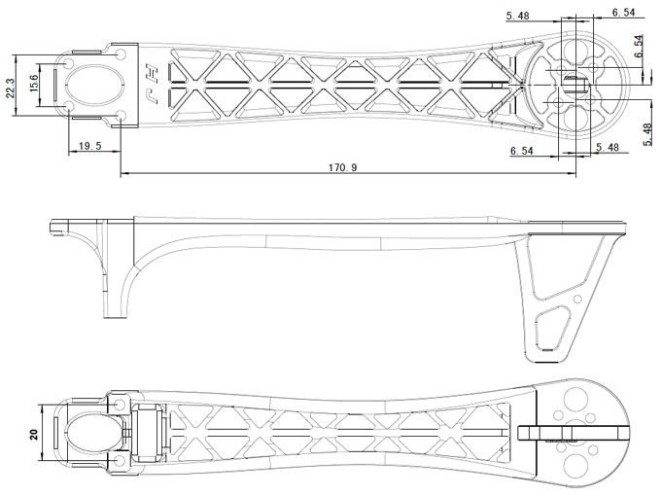

### Length

The length of the drone initially is 170.19mm and it will be modified to 100.19mm for more stability and smaller mass.

### Thickness

The thickness of the drone varies throughout the drone’s profile. Its average thickness is of 12.84mm

The thickness is going to be set to 10mm as it is ideal for our drone.

### Width The width also varies along the profile from 30mm at one end to 20mm in the middle back to 30mm and the diameter at the other end where the motor is placed is 4mm

Only the diameter will be modified and set to 5mm so as to have a larger protective distance for the motor

### Geometry:

Addition material will be added round the motor area for more protection of the motor.

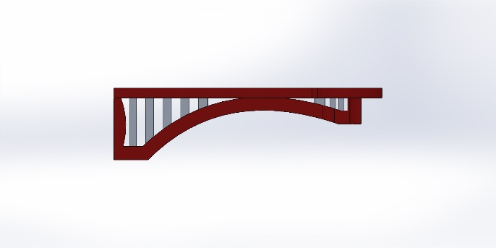Additional structure will be added over all the drone’s arm length for more support.

Additional pieces like propellers protections are to be added.

## DRONE’S MATERIAL

**• Mass of the drone arm**

TO BE DONE IN THE LABORATORY

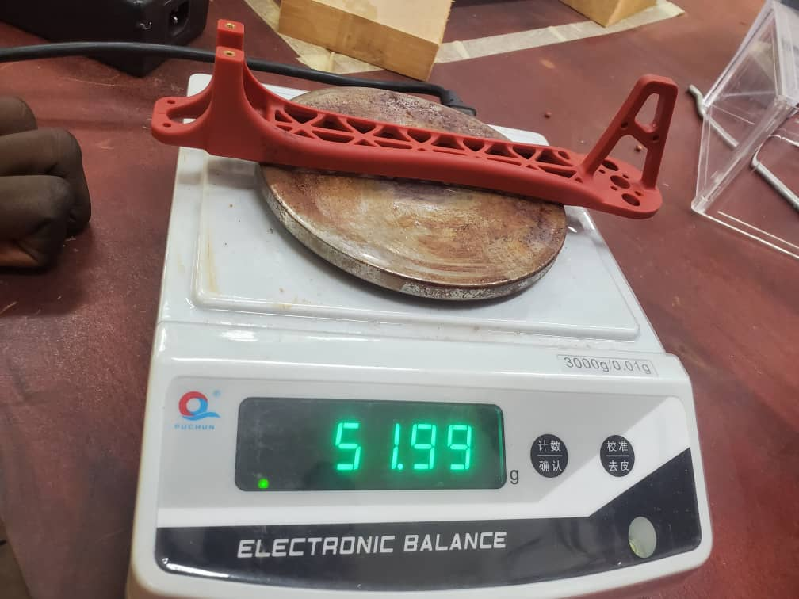

**• Choice of substituted material**

Our initial drone arm was made of fiberglass + PLA, materials suitable for this kind of application. With a view to optimization, we opted for an arm made of Aluminum + Carbon fiber.

1. Aluminum is a lightweight yet strong material, making it a popular choice for drone arms. Drones need to be light in order to fly more easily, but they also need to be tough to withstand different flight conditions.

2. Aluminum is also a long-lasting material that resists to corrosion and wear. This means the aluminum arms can last a long time and requires little maintenance.

3. Aluminum drone arms also have the advantage of being easily customizable. They can be cut or bent to fit different sizes and shapes of drones.

This combined with the strength and rigidity of carbon fiber, we will obtain a composite material of choice for our drone arm having the following characteristics;

• High tensile and compressive strength

• A high modulus of elasticity i.e. a high rigidity

• Low density

• Excellent chemical resistance

• Excellent temperature resistance

• Good electrical conduction

**Mass of the new arm**

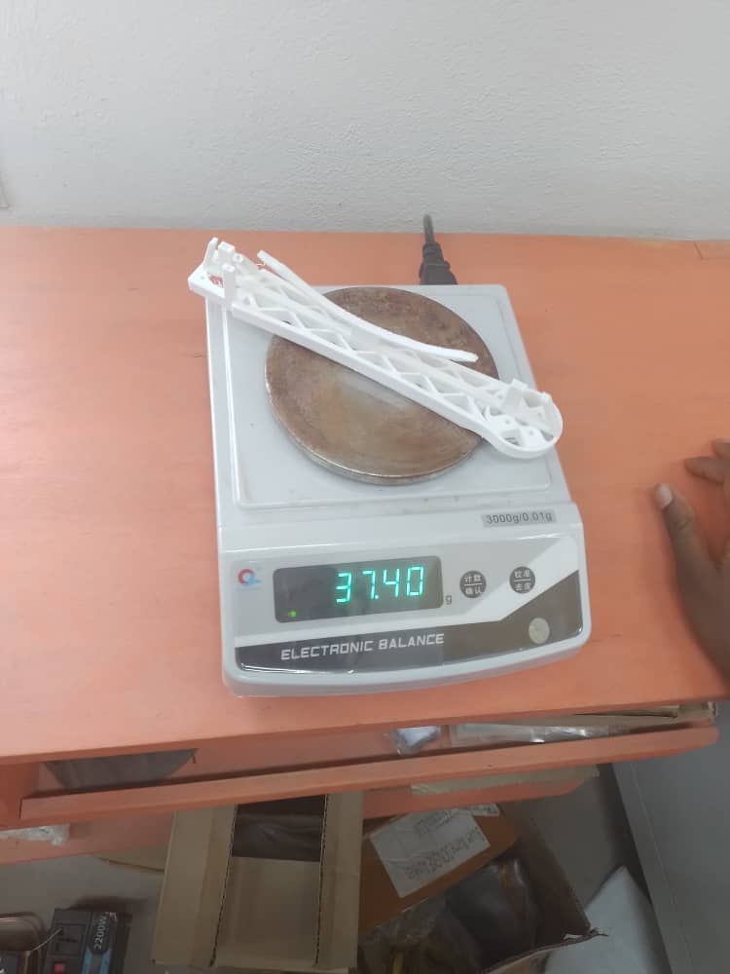

**Dimension modification**

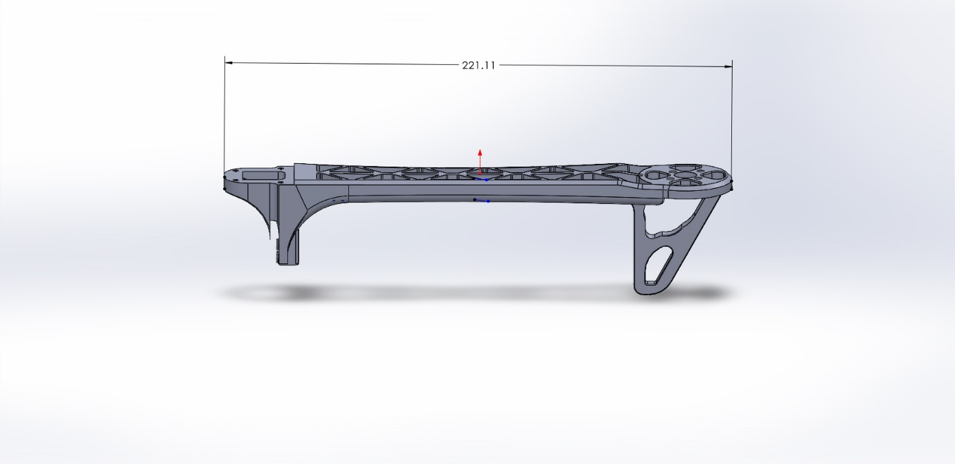**`**

### BEFORE

| **Material** | **Tensile strength**  **(MPa)** | **Young’s modulus (GPa)** | **Maximal Elongation (%)** | **Density**  **(g/cm3) Strength to weight**  **ratio** | **Rapport résistance/poids (MPa/g/cm3)** |
| --- | --- | --- | --- | --- | --- |
| Glass fiber | 4600 | 88 | 5.5 | 2.49 1847 | 1847 |
| PLA | 20 | 2.85-4.14 | 5-10 | 1.25-1.28 2535 | 2535 |
| Carbon fiber | 5407 | 294 | 1.75 | 1.79 3026 | 3026 |
| Aluminum 6061-T6 (3) | 310 | 68.9 | 17 | 2.7 135 | 115 |

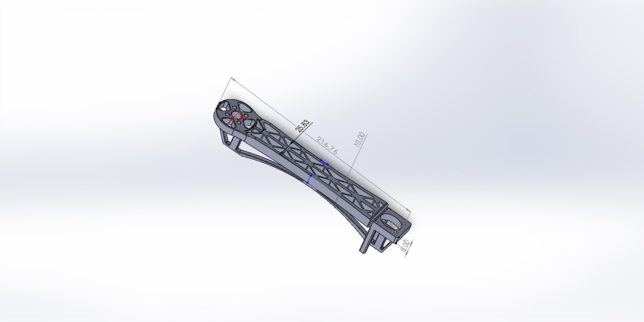

### AFTER